

**Research Essay on Cyber Bullying**

# Prepared By

Vrajesh Choksi – 21801861

# *Program tutor:*

Simon Dixon

**BACHELOR OF INFORMATION TECHNOLOGY**

**Communication in IT - IT5502**

# Introduction

In last few years internet and technology have grown enormously. People above age of 12 years are addicted to the technology and internet for various purpose. This kind of addiction has paved way to the formation of new type of bullying called as cyber bullying. Bullying has been there for a long time and consider as hard to explain because of change in time. The advancement in social networking sites such as Facebook, Twitter, Instagram, and Snapchat are the major reason for the development of cyber-bullying. Currently there is a sudden rise in cyber bullying incidents happening at different social networking sites due to large crowd. The trigger person will always choose social networking medium as due to existence of more people and to show their clout and other persons weakness in front of others. They will choose victim who is shy and weak to talk regarding problem in their life.

# History OF Bullying

As author Campbell (2005) mention that, in the early part of human lives’ bullying was not given that much attention and was not seen as a major problem. Early 70’s and 80’s people accepted bullying and even went to extent of considering it as fundamental and essential part of childhood. Afterall, in last few decades, a lot of change can be seen in and it consider as one of the serious problems which needs an critical attention. According to the author Campbell (2005), any form of abusive treatment of a person is considered as bullying. An aggressive behavior which is repeated over a period and can’t be intentionally or unintentionally harmful to a person without any provocation. Physical bullying behaviors append of punching, hitting or splitting. In time of bullying involves usage of foul languages, verbal assault, teasing, and scapegoating. Normally bullying involves a minimum of two people one would be the perpetrator and the other one is a victim. In some conditions, it may involve a huge number of people in an indirect way as the audience. This audience are called “bystanders”, who witness the bullying events but remain silent or uninvolved. They do not interfere when a bullying happens because they are afraid of becoming the next victim. These bystanders are powerless who show loss self-respect and confidence.

# Cyber Bullying

Smith, Mahdavi, Carvalho, & Tippett (2006) says, cyberbullying is an aggressive, intentional act which is carried out by an individual or group using an electronic medium like mobile phones, personal computer, laptops and personal digital assistants (PDA). Typically, cyber-bullying happens on a person who can’t defend him or herself which is as similar to traditional bullying. The expansion of cyberbullying is more in recent years because of the increase in usage of electronic mediums. There are many forms of cyberbullying and the authors Smith, Mahdavi, Carvalho, & Tippett (2006) have classified them into seven subcategories.

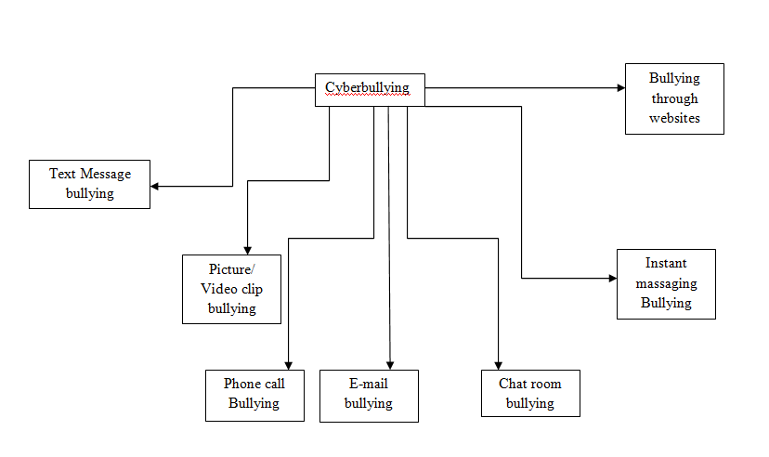

*Figure 1*: Seven Subcategories of Cyber-bullying (Smith, Mahdavi, Carvalho, & Tippett, 2006)

According to Serra and Venter (2011), cyberbullying has the ability to communicate without revealing the identity of a person and also without the fear of reprisal. Cyberbullying helps the individual to seek revenge on that person for transgression in the real world. It helps the person to project differently which may contrast with individuals real-world personality. Cyberbullying happens through various mediums such as websites, blog, forums, voice and also through text messages. It also happens through social media’s like facebook, Instagram, twitter etc (Serra & Venter, 2011).

# TYPES OF CYBERBULLYING

Serra and Venter (2011) has classified cyberbullying into six types which are (Serra & Venter, 2011),

1. FLAMMING- It means commenting aggressive and rude comments either in individuals’ photos or videos.
2. HARASSMENT- Harassment means sending offensive messages repeatedly.
3. DENIGRATION- Spreading of rumors or false information about others in social media.
4. OUTING & TRICKERY- It means talking to someone into disclosing their private information which is then spread widely.
5. IMPERSONATION- Posting information to spoil a person’s reputation by pretending to be that person.
6. EXCLUSION- Excluding a person for online group intentionally.

# STATISTICS OF CYBERBULLYING

Educators and research scientist have come up with a lot of methods to find the statistical impacts of cyber-bullying. Research is done in all parts of the world to find which age group of people gets affected the more because of cyber-bullying. They also found that the common mediums of cyber-bullying were through phone calls, Email and Text messages. Mostly Internet bullying happens outside of school since they do not require any physical environment. Li (2006) says gender also play an important role in traditional bullying and cyber-bullying. In order to prove that she selected middle schools randomly in Canada and a total of 264 students (134 females and 130 males) from grade 7-9 completed the questionnaires. This made Li (2006), to prove that gender difference also plays a major role in cyber-bullying. Females were significantly cyber-bullied through text message, phone calls, and E-mail (Li, 2006).

# IMPACTS OF CYBERBULLYING

According to the study of Slonje and Smith (2008) show that the influences for cyber-bullying can be anything and can be classified into two types. The two types of cyber-bullying are internal and external. Internal cyber-bullying happens because of boredom, jealousy or at times to get revenge. External cyber-bullying happen when the perpetrator does not want to have a face to face encounter with the victim. Be it the traditional bullying or cyberbullying both have its own form of negative impacts on the victim lifestyle. Since cyberbullying happens in social media like Facebook, Twitter, and Instagram, the impact of it is larger due to the presence of a larger audience. Due to the presence of a huge number of audiences, the victim feels embarrassment, shyness, and shame.The after effect of cyberbullying is mental stress like angriness, depression, stress, afraid, defenseless and helplessness. These impacts are considered to have more effects than traditional bullying. The impacts are found high in Internet bullying and lowest in mobile bullying. Smith, Mahdavi, Carvalho, & Tippett (2006) found that, each classification of cyber-bullying has its own impacts. Bullying which happens through the picture, video clips, and phone are perceived to have a longer impact on the victim than the traditional form of bullying.

**REMEDIES OR PREVENTION OF CYBERBULLYING**

Liberman, Dinakar, and Jones (2011) say, detecting a message for cyber bullying is much more difficult than finding a spam. They had also found that cyber-bullying happens due to a small number of topics also which are race, ethnicity, sexuality, physical appearance and intelligence. In order to find those hidden meaning in the messages, the author came up with the design of social network software which can control the growth of cyber-bullying. This software can take many forms such as videos, stories or interactive manners. The software helps the cyber-bullies to develop empathy on the victim and warn the bully about the possible damage to their reputation. The software helps the victim to seek emotional support and also helps them to learn on how other would have dealt with their problem. This software also helps the victim ’s friend to join him and defend together (Liberman, Dinakar, & Jones, 2011).

# Conclusion

The cost to persons, communities and interventions are extensive. According to Sense Partner (2018) estimate the cost of cyberbullying was $444m in 2018. They used local surveys, international studies, and approaches from other fields to develop a framework and identify the costs. Additional interventions against cyberbullying could focus on:

•Destigmatising asking for help, 31% of those facing or beholding cyberbullying did not seek help.

•Investing in curriculum for schools. Young people are excessively affected by cyberbullying.

•Raising consciousness of cyberbullying and where to seek help. Victims of cyberbullying are most likely to turn to their family and friends for help. Awareness of where to go for help would be valuable.

# REFERENCE

Bosse, T., & Stam, S. (2011). A normative agent system to prevent cyberbullying. In *Proceedings of the 2011 IEEE/WIC/ACM International Conferences on Web Intelligence and Intelligent Agent Technology-Volume 02* (pp. 425–430). IEEE Computer Society.

Campbell, M. A. (2005). Cyber bullying: An old problem in a new guise? *Journal of Psychologists and Counsellors in Schools*, *15*(1), 68–76.

Content analysis - what is content analysis? (n.d.). Retrieved September 2, 2018, from http://www.audiencedialogue.net/kya16a.html

Garett, R., Lord, L. R., & Young, S. D. (2016). Associations between social media and cyberbullying: a review of the literature. *MHealth*, *2*. <https://doi.org/10.21037/mhealth.2016.12.01>

Holsti, O. R. (1969). Content analysis for the social sciences and humanities. *Reading. MA: Addison-Wesley (Content Analysis)*.

Kirppendorff, K. (1989). Content analysis: An introduction to its methodology. *Beverley Hills: Sage*.

Li, Q. (2006). Cyberbullying in schools: A research of gender differences. *School Psychology International*, *27*(2), 157–170.

Serra, S. M., & Venter, H. S. (2011). Mobile cyber-bullying: A proposal for a pre-emptive approach to risk mitigation by employing digital forensic readiness. In *Information Security South Africa (ISSA), 2011* (pp. 1–5). IEEE.

Slonje, R., & Smith, P. K. (2008). Cyberbullying: Another main type of bullying? *Scandinavian Journal of Psychology*, *49*(2), 147–154.

Smith, P. K., Mahdavi, J., Carvalho, M., & Tippett, N. (2006). An investigation into cyberbullying, its forms, awareness and impact, and the relationship between age and gender in cyberbullying. *Research Brief No. RBX03-06. London: DfES*.

Snakenborg, J., Van Acker, R., & Gable, R. A. (2011). Cyberbullying: Prevention and intervention to protect our children and youth. *Preventing School Failure: Alternative Education for Children and Youth*, *55*(2), 88–95.

Stemler, S. (2001). An overview of content analysis. *Practical Assessment, Research & Evaluation*, *7*(17), 137–146.